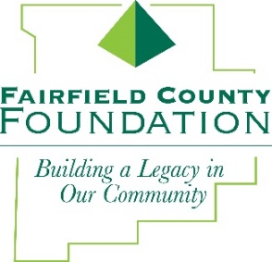

NEWS RELEASE
FOR IMMEDIATE RELEASE November 2, 2017

Fairfield County Foundation Donates $30,000 to Local Food Pantries

LANCASTER, Ohio --The Fairfield County Foundation has donated $30,000 to local food pantries in Fairfield County this holiday season. The donation is distributed throughout the county – going to 13 different pantries in nearly every local community—and came from the George and Dollie L. Zimpfer Memorial Fund.

“The Fairfield County Foundation has made it a priority to contribute to the local food pantries that help meet the basic needs of our citizens throughout the year, and especially during the busy holiday season,” said Amy Eyman, Executive Director of the Fairfield County Foundation. “Given the continuing struggle many members of our community face to make ends meet, we know that our food pantries are serving more and more individuals and families every day. As such, we are pleased to be able to provide an additional $5,000 in funding this year.”

Donations went to the following food pantries:

- Baltimore-Thurston Area Food Pantry
- Bremen Food Pantry
- Canal Winchester Human Services Food Pantry
- The Foundation Dinners
- The Key to Giving
- Lancaster-Fairfield Community Action Agency
- Lancaster Vineyard Food Pantry
- Lutheran Social Services of Fairfield County
- Maywood Mission Food Pantry
- Millersport Community Food Pantry
- PCMA Food Pantry of Pickerington
- Salvation Army of Fairfield County Food Pantry
- St. Vincent DePaul of Lancaster Food Pantry

About the Fairfield County Foundation:
The Fairfield County Foundation is a 501 (c) (3) non-profit that along with its supporters, helps to sustain and enhance the quality of life and economic viability in our community. Its scholarship program helps to sustain opportunities for local youth to achieve their academic goals. The Foundation was formed in 1989 and grants today continue to support the arts, children’s programs, health and wellness projects, community development, academics, and more. For more information about the Foundation, please call 740-654-8451 or visit www.fairfieldcountyfoundation.org.
###

