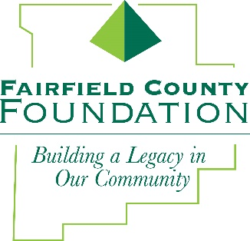
NEWS RELEASE
FOR IMMEDIATE RELEASE October 31, 2018

Fairfield County Foundation Announces Grant Deadlines for 2019

LANCASTER, Ohio – The Fairfield County Foundation has announced the 2019 Grant Cycle Deadlines. Implemented in 2018, the three cycle application structure expands opportunities for nonprofit organizations serving Fairfield County to receive funding support.
“We are honored to have the opportunity to support so many organizations that are doing incredible work in our community through our grant program,” said Amy Eyman, Executive Director of the Fairfield County Foundation. “Introducing the additional cycle increased applications by 40 percent in 2018. We hope to see even more organizations taking advantage of the funds available through our grant program in 2019.”
Following are the deadlines for the 2019 grant cycles:
CYCLE 1:
- Preliminary Grants: Due second Monday in January – January 14, 2019
- Invitations to submit full grant sent second week of January
- Grant Application: Due second Monday of February – February 11, 2019
- Grant Committee recommendation to Board of Trustees for approval – March 21, 2019
CYCLE 2:
- Preliminary Grants: Due second Monday in May – May 13, 2019
- Invitations to submit full grant sent second week of May
- Grant Application: Due second Monday of June – June 10, 2019
- Grant Committee recommendations to Board of Trustees for approval – July 18, 2019
CYCLE 3:
- Preliminary Grants: Due second Monday in September – September 9, 2019
- Invitations to submit full grant sent second week of September
- Grant Application: Due second Monday of October – October 14, 2019
- Grant Committee recommendations to Board of Trustees for approval – November 21, 2019

To view grant deadlines and preliminary grant application, visit fairfieldcountyfoundation.org/grants/

About the Fairfield County Foundation:
The Fairfield County Foundation is a 501 (c) (3) non-profit that along with its supporters, helps to sustain and enhance the quality of life and economic viability in our community. Its scholarship program helps to sustain opportunities for local youth to achieve their academic goals. The Foundation was formed in 1989 and grants today continue to support the arts, children’s programs, health and wellness projects, community development, academics, and more. For more information, call 740-654-8451 or visit www.fairfieldcountyfoundation.org.
###
MEDIA CONTACT: Jill Buterbaugh, 614/326-9054, jill@krilecommunications.com

