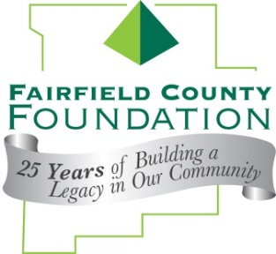
FOR IMMEDIATE RELEASE April 7, 2016

Fairfield County Foundation to Celebrate 27-Hour Give on #GivingTuesday
Invites local non-profit organizations to GET YOUR GIVE ON in November!

LANCASTER, Ohio --The Fairfield County Foundation is again this year giving non-profit organizations an opportunity to “Get their Give On” during a 27-Hour Give event; however, this year the event will be held in conjunction with #GivingTuesday, which is held annually on the Tuesday after Thanksgiving (in the U.S.) to kick-off the holiday giving season and inspire people to collaborate in improving their local communities.

The 27-Hour Give will begin at 8 a.m. on #GivingTuesday, November 29th, and donations will be accepted until 11 a.m. on Wednesday, November 30th.

“#GivingTuesday encourages community members to make a charitable contribution to a fund at the Fairfield County Foundation, or to any cause or charity they are passionate about, so it makes perfect sense for us to combine our annual timed Give event with this day that promotes giving back,” said Executive Director of the Fairfield County Foundation, Amy Eyman. “We are also bringing the donation process online this year, which will make donating easier and give more organizations the opportunity to benefit from our match.”

How it works:
- Any donor or non-profit wishing to receive matching funds during the 27-Hour Give must have a fund at the Fairfield County Foundation as all donations and matching dollars will be added to the designated fund.
- Donors and non-profit organizations should secure new donations from individuals — that must be made online at www.fairfieldcountyfoundation.org through the Donate Now link—during the event’s specified date and time. Donations taken in the office will not count toward the match.
- At least $27,000 in matching gifts will be awarded. All donations received during the 27-Hour Give will be eligible for matching funds on a pro rata basis, which gives everyone who participates the opportunity to have their donations increased.
- The matching gifts will be distributed based on the percentage each fund receives of the total contributions made during the 27-Hour Give. For example, a fund with donations that account for 5% of the total 27-Hour Give contributions would receive 5% of the $27,000 in matching funds, or $1,350.

If you have any questions about the 27-Hour Give, please contact Amy Eyman at 740-654-8451 or aeyman@fairfieldcountyfoundation.org.

About the Fairfield County Foundation:
The Fairfield County Foundation is a 501 (c) (3) non-profit that along with its supporters, helps to sustain and enhance the quality of life and economic viability in our community. Its scholarship program helps to sustain opportunities for local youth to achieve their academic goals. The Foundation was formed in 1989 and grants today continue to support the arts, children’s programs, health and wellness projects, community development, academics, and more. For more information about the Foundation, please call 740-654-8451 or visit www.fairfieldcountyfoundation.org.
###

