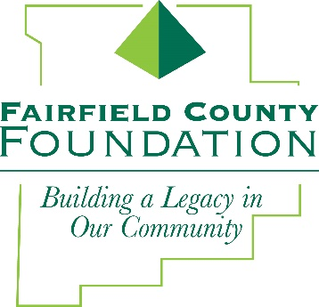
FOR IMMEDIATE RELEASE October 4, 2017

Fairfield County Foundation to Celebrate 28-Hour Give on #GivingTuesday

LANCASTER, Ohio –The Fairfield County Foundation is once again providing community members an opportunity to “Get Their Give On” during a 28-Hour Give event held in conjunction with #GivingTuesday, which takes place annually on the Tuesday after Thanksgiving (in the U.S.) to kick-off the holiday giving season and inspire people to collaborate in improving their local communities.

This year, the Foundation will award $28,000 in gifts, matching online donations made over 28 hours, starting on November 28th at 8am through 12pm on Wednesday, November 29th.

“Over the past four years, the Foundation has generated more than $250,000 in charitable donations during our #GivingTuesday events,” said Amy Eyman, Executive Director of the Fairfield County Foundation. “We are truly grateful to our donors and supporters throughout Fairfield County who have made our annual Give events such a success for the community.”

How it works:
- Any donor or non-profit wishing to receive matching funds during the 28-Hour Give must have a fund at the Fairfield County Foundation as all donations and matching dollars will be added to the designated fund.
- Donors and non-profit organizations should secure new donations from individuals — that must be made online at www.fairfieldcountyfoundation.org through the Donate Now link—during the event’s specified date and time. Donations taken in the office will not count toward the match.
- At least $28,000 in matching gifts will be awarded. All donations received during the 28-Hour Give will be eligible for matching funds on a pro rata basis, which gives everyone who participates the opportunity to have their donations increased.
- The matching gifts will be distributed based on the percentage each fund receives of the total contributions made during the 28-Hour Give. For example, a fund with donations that account for 5% of the total 28-Hour Give contributions would receive 5% of the $28,000 in matching funds, or $1,400.

If you have any questions about the 28-Hour Give, please contact Amy Eyman at 740-654-8451 or aeyman@fairfieldcountyfoundation.org.

About the Fairfield County Foundation:
The Fairfield County Foundation is a 501 (c) (3) non-profit that along with its supporters, helps to sustain and enhance the quality of life and economic viability in our community. Its scholarship program helps to sustain opportunities for local youth to achieve their academic goals. The Foundation was formed in 1989 and grants today continue to support the arts, children’s programs, health and wellness projects, community development, academics, and more. For more information about the Foundation, please call 740-654-8451 or visit www.fairfieldcountyfoundation.org.

###
Media Contact: Jill Buterbaugh, Krile Communications, 614/326-9054, jill@krilecommunications.com

