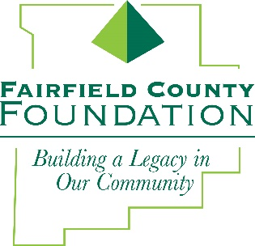
FOR IMMEDIATE RELEASE January 8, 2018

Fairfield County Foundation Welcomes New Board Members

LANCASTER, Ohio --The Fairfield County Foundation has recently welcomed four new members to its Board of Trustees: Jeff Beard, Aundrea Cordle, Mike Lieber and Melissa Walker.

“The Foundation is pleased to welcome these outstanding leaders in our community to our Board of Trustees,” said Amy Eyman, Executive Director of the Fairfield County Foundation. “We’re looking forward to their contributions to our Foundation and our community.”

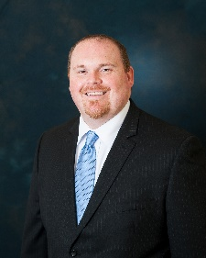
Jeff Beard holds a Bachelor of Business Administration from Tiffin University and a Master of Business Administration from Capital University. In addition, Jeff completed the Graduate School of Banking in Madison, Wisconsin and is a Certified Public Accountant. He currently serves as the President and CEO of Standing Stone National Bank and SSNB, Inc., a position he has held since January 2013. Jeff completed the Fairfield Leadership program and is active in the Lancaster Rotary. He serves a number of local organizations, including: United Way of Fairfield County Impact Council, Big Brothers Big Sisters of Fairfield County Board of Directors (Treasurer), Fairfield 33 Development Alliance Board of Directors, Ohio Bankers League BankServices Board of Directors and the Tiffin University Alumni Association Board of Directors (Chairman).

Aundrea Cordle earned her Bachelor of Science in Communications and Master of Business Administration degrees from Ohio University. She has spent her career as a public servant with Fairfield County Job and Family Services, where she has worked in a variety of roles that led her to the Director position in 2014. Aundrea has served on the Robert K. Fox Family Y Board of Directors for the past 15 years. She is a former Board Member of Fairfield County Red Cross and the campaign chair for the Government Division of The United Way of Fairfield County. In addition, she is an active volunteer for Lancaster City Schools, over the years serving as a Board of Education member, co-chair on several bond and levy committees, the Chair of the Distinguished Alumni Hall of Fame Selection Committee, a member of the Marketing Education Advisory Committee and PTO president.

Mike Lieber is a graduate of The Ohio State University with a Bachelors of Arts in Journalism. A recent retiree, Mike spent the last 12 years of his career as Executive Director for the Robert K. Fox Family YMCA, where he oversaw the operation of a $2.5 million non-profit with 100 employees. During his tenure, he facilitated the purchase of the RecPlex facility, which has allowed the Y to offer the community additional activities including indoor tennis, baseball, volleyball and gymnastics. Mike is a member of the Lancaster Rotary and was recently elected to serve on the Board of Directors.

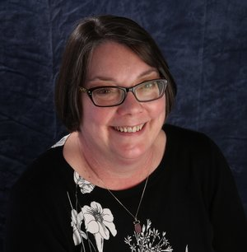
Melissa Walker is a life-long Lancaster resident and owner of Walker Shoe Center, the second oldest family-owned shoe store in the nation and a mainstay on Main St. in Lancaster since 1960. Melissa started working in her father’s shoe business in 1976. After graduating from Lancaster High School, studying business at Ohio University and time honing her skills at a Stride Rite store and in the family business, Melissa purchased Walker Shoe Center in 2000. The shoe store received the Small Business of the Year Award from the Lancaster Fairfield County Chamber of Commerce in 2014 and the Ethical Business Award from The Lancaster Rotary Club and the Eagle Gazette in 2016. Melissa is a proud supporter of various local community organizations, including the Lancaster Noon Rotary, where she is the past president, and the Harcum House, where she serves as a board member.

About the Fairfield County Foundation:
The Fairfield County Foundation is a 501 (c) (3) non-profit that along with its supporters, helps to sustain and enhance the quality of life and economic viability in our community. Its scholarship program helps to sustain opportunities for local youth to achieve their academic goals. The Foundation was formed in 1989 and grants today continue to support the arts, children’s programs, health and wellness projects, community development, academics, and more. For more information about the Foundation, please call 740-654-8451 or visit www.fairfieldcountyfoundation.org.
###

